# **Scrum Master Payscale**

[joelhrobinson@gmail.com](mailto:joelhrobinson@gmail.com)

this is a snapshot of some interesting statistics on scrum.

Source: <https://www.payscale.com/research/US/Job=ScrumMaster/Salary>

All rights reserved by originator

The average pay for a ScrumMaster is $82,556 per year. Most people move on to other jobs if they have more than 20 years' experience in this career. A skill in Software Development Management is associated with high pay for this job.

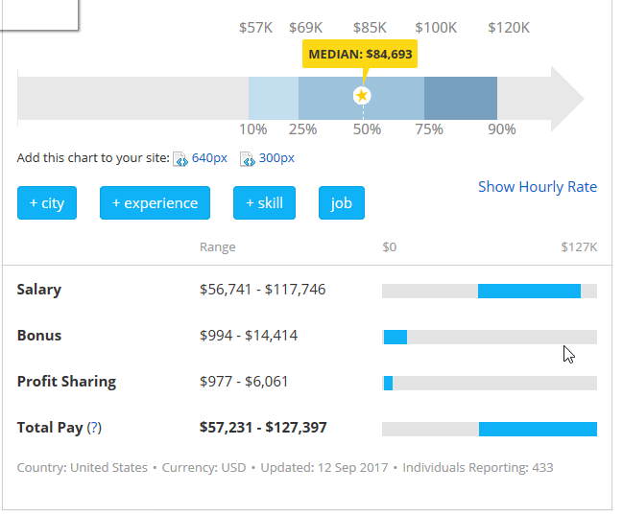 Job Description for ScrumMaster

A scrummaster's main responsibility is making sure that the day-to-day operations related to software development are performed effectively and efficiently. They support a cross-functional team to remove obstacles that could hinder progress, build strong relationships with program owners and application users, and ensure the successful delivery of all tasks and projects. Additionally, they are in charge of assisting the team by driving daily scrums, tracking progress, and perform reviews.

[Read More...](javascript:void(0);)

ScrumMaster Tasks

Lead a team in design, implementation, testing and validation of programming code and products.

Document and communicate expectations, resolutions and product information.

Set schedules, facilitate discussions and resolve problems.

Guide and shape team-oriented behaviors and interactions.

ScrumMaster Job Listings

[ScrumMaster](https://www.ziprecruiter.com/clk/agile-transformation-6ba09c8d-scrummaster-4ee48fcc?clk=xVaz8XS_YJ3F9_3R3CrabYQuAcP-Kxe94c0hUpsd4gTkwGXdWSEENoAGZ9yLoxg19gXYGXcuBhHB4vaU_P-Svmmw69mWZBZpbIMUcN99MGHDyzXWgDuAjmkzngF8sQHLs8Q6SatqaRZnvNsBcEPG_8dOf8w4LZKpr2HpZ9yFrCcKaVaxBcNXFPVpiqFFrxxI5ALd1_a-K-ZuuAC8gosIySayZV27hzDlgT2thHUYqQeBKRruYrqCm9XfqfwoExjR6zaXzhH2Pqv3HNvpY92BGDeWm60qmVEWUMdONJlu-tc5_CcBd2jNWR6oyspnx-_THkBfxYm3Ffzgt6r3dknrvj5WvRC4G-yhNOsTScUGzS5CicilfqKnPfhMOIlncXb6aWPWXmSydrTcM5070GzqCLo4AsKadh2NIf8TotUX0kcHN2EZPh5NwqIbXnduuPl0-V8nIsR-C71YSS1-7OvAvDVmLrXdi0-QNpfGVBE7RZQsS25DxYdOkLhQpdfkQ_sE6HcJnIxyBjg9uHMyqC_rB1w47UTSh6be-jHzCVJpTv5teJgBdcdCnBa0_fu-gZGmmcwE1Wx89WK8ofD_ePQ-8e4FXI7S0hng7gl0W_cGkwU.955686daef9517d9f98b5be9c816801b)

Sep 6

Agile Transformation

Omaha, NE, USA

Agile Transformation, Inc., a dynamic, fast-paced, high-performance transformation company, is looking for a full-time **ScrumMaster** & Business Analyst. We are looking for someone who can join our team ...

Popular Skills for ScrumMaster

ScrumMasterAgile Software DevelopmentAgileProject ManagementScrum

*This chart shows the most popular skills for this job and what effect each skill has on pay.*

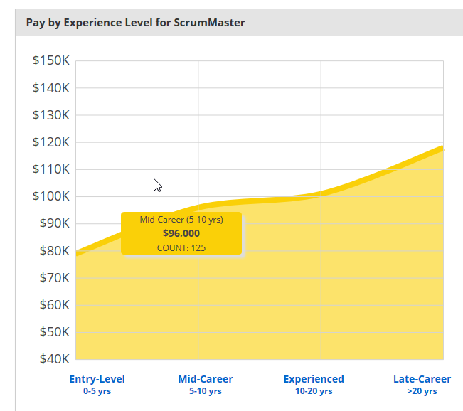 Pay by Experience for a ScrumMaster has a positive trend. An entry-level ScrumMaster with less than 5 years of experience can expect to earn an average total compensation of $79,000 based on 258 salaries provided by anonymous users. Average total compensation includes tips, bonus, and overtime pay. A ScrumMaster with mid-career experience which includes employees with 5 to 10 years of experience can expect to earn an average total compensation of $96,000 based on 125 salaries. An experienced ScrumMaster which includes employees with 10 to 20 years of experience can expect to earn an average total compensation of $101,000 based on 82 salaries. A ScrumMaster with late-career experience which includes employees with greater than 20 years of experience can expect to earn an average total compensation of $118,000 based on 22 salaries.

Pay Difference by Location

National Average: $88,717

Larger city markers indicate a job is popular in that location.

[Learn about cost of living by city »](https://www.payscale.com/cost-of-living-calculator)

ScrumMaster Reviews

Q: What is it like working as a ScrumMaster?

**ScrumMaster** in Encino:

**"Good times."**

**Pros:** Collaborative work experience, multi-cultural and diverse, work with people all around the world, work from home full-time, strong company.

**Cons:** Schedule can be difficult.

Related Job Salaries

